 [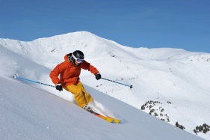](https://www.google.com/url?sa=i&rct=j&q=&esrc=s&source=images&cd=&cad=rja&uact=8&ved=0ahUKEwjXluHs2_LRAhWCjlQKHSgVBrgQjRwIBw&url=http://www.playbuzz.com/michaelr23/what-kind-of-skier-are-you&psig=AFQjCNGiCNGvkZI6nis9-Z4cw4yBbGwmkg&ust=1486169675552223) [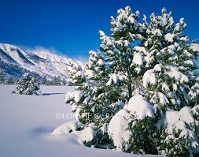](https://www.google.com/imgres?imgurl=http://cdn.c.photoshelter.com/img-get/I0000Gk3qtNu0oho/s/850/850/Snow-Covered-Tree-Photo-ES-1889-Londie-G.jpg&imgrefurl=http://londie.photoshelter.com/image/I0000Gk3qtNu0oho&docid=rZ_WEPkhLN-vcM&tbnid=L35XNHiszpDPdM:&vet=1&w=850&h=668&safe=off&bih=651&biw=1366&q=snow%20covered%20seirra%20nevada%20mountains&ved=0ahUKEwidud6v3fLRAhVpwVQKHcU4Co8QMwhHKB4wHg&iact=mrc&uact=8)

**What:** An Evening of a Panel of Experts on Health, Orthopedics, and Performance

**When:** Wednesday, March 8th 5:00PM-7:30 PM

**Where:** Active Physical Therapy, 3594 W. Plumb Lane Reno, NV

**Who:** Physicians, Physician Assistants, Nurses, Personal Trainers, Gym Owners, Patients, Athletes, Coaches, Health Enthusiasts

5:00- 5:12: **Nora Constantino, PhD,** Exercise Physiologist, Professor UNR, Reno, NV

“Exercise Induced Rhabdomyolysis”

5:12- 5:24: **Michael Ries, MD,** Orthopedic Surgeon, Reno Orthopedic Clinic, Reno, NV

“Current Update on Lower Extremity Injuries”

5:24- 5:36: **Cammie Craig,** Personal Trainer, Cammie Craig Fitness, Reno, NV

“Undertraining vs. Overtraining”

5:36- 5:48: **Jeffery Muir , MD**, Rehabilitation and Pain specialist, Sweetwater Pain and Spine, Reno, NV

“Radio Frequency Ablations for Spine Pain”

5:48- 6:00: **Quinn Pauly , MD**, Family Practice, Renown Health Premiere Care, Reno, NV

“Vascular Imaging”

6:00- 6:12: **Michael Lilyquist, MD**, Orthopedic Surgeon, Great Basin Orthopedics, Reno, NV

“Current Update on Upper Extremity Injuries”

6:12- 6:15: **Michael Spevak, DPT and** **Parley Anderson,** **DPT,** Owners of Active Physical Therapy, Reno, NV

“A Simple Stretch for Fixing Neck Pain”

6:15- 6:30: **Free Paleo Food!**

6:30- 6:42: **Sanjai Shukla, MD**, Orthopedic Surgeon, Reno Orthopedic Clinic, Reno, NV

“Current Update on Knee Injuries”

6:42- 6:54: **Paul Shonnard**, **MD**, Orthopedic Surgeon, Nevada Orthopedics, Reno, NV

“Current Update on Orthopedics”

6:54- 7:06: **Tom Rammel- DC,** Chiropractor, The Back Doctors, Reno, NV

“Spine Health”

7:06-7:18: **Ellie Holbrook,** Clinical counselor, Yoga instructor, Yoga w/ El, Reno, NV

“Benefits of Yoga”

7:18-7:30: **TBD**