

Location: 3954 West Plumb Lane, Reno, NV 89509

Contact: Call (775) 786-2400

Text: (775) 440-7902

**Knee Health**

With our spring seminar around the corner we wanted to review a topic discussed last October in our fall seminar, knee health.

Many people experience all sorts of knee pain and Dr. Spevak and Dr. Anderson discussed two of the best stretches that are simple yet effective in keeping the knees healthy and mobile. For the back of the knee the stretch they discussed is called an extension stretch. What you do is as depicted in the box on the right, while sitting in a chair or standing, place your foot out and bring your toes up into what we call dorsiflexion. Then apply a little pressure by pushing down on your thigh which will stretch out all the muscles, tendons and ligaments in the back of the knee.

The other important stretch is flexion which helps to improve the front of the knee and all around knee mobility. As depicted to the right you will start on your hands and knees then bend your knees trying to get your heels to your butt.

**Save the Date**

Don’t miss out! On Wednesday March 8th from 5-8pm is our Spring Health Seminar. Come to the Active Physical Therapy clinic to enjoy a night of different health experts and doctors discussing a range of health related topics. Free food and drinks will be provided!



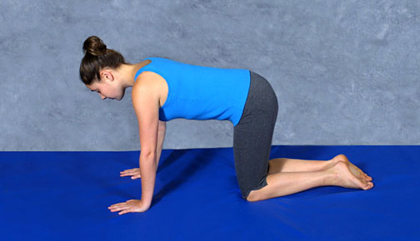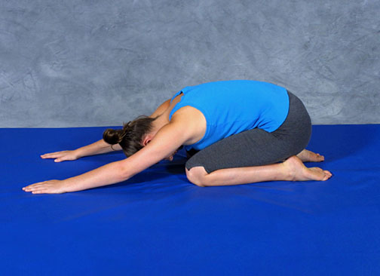

**Fun Fit Fact**

 The load distributed over the kneecap can be up to 5 times the body weight, particularly on going down stairs.

Knee Flexion Stretch

Knee Extension Stretch