Location: 3954 West Plumb Lane, Reno, NV 89509
Contact: Call (775) 786-2400

Halloween Health Fact

Tis the season for pumpkin everything! A way you may not have thought to include pumpkin is for your post workout snack. A cup of cooked pumpkin contains 564 milligrams of potassium, an important refueling nutrient, beating out bananas which only have 422 milligrams.

Text: (775) 440-7902

Fall Conference

Our Active Physical Therapy health conference was a huge success. The conference was held at our office and we had 14 speakers present information on a variety of topics including concussion management, shoulder instability, hand injuries, and much more. Our very own Michael Spevak and Parley Anderson demonstrated simple stretches that keep knee joints healthy and strong. Another presenter, Ryan Evans, spoke about Recharge, a local business that focuses on stimulating physical recovery following exercise. Attendees enjoyed free paleo food during the conference and gained valuable information to maintain their health. Join us for all the fun at our next free seminar in March 2017!
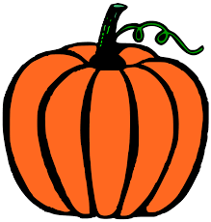
Fun Fit Fact

In one day, the average individual’s heart exerts enough power to lift a 1-ton weight more than 40 feet off the ground.
Trivia

Q: What is the smallest muscle in the body?
A: The Stapedius
- The stapedius, located in the inner ear, is the smallest skeletal muscle in the human body. At just over one millimeter in length, its purpose is to stabilize the smallest bone in the body, the stapes.

