 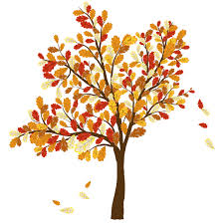

**What:** An Evening of a Panel of Experts on Health, Orthopedics, and Performance

**When:** Wednesday, October 19th 5:00PM-8:00 PM

**Where:** Active Physical Therapy, 3594 W. Plumb Lane Reno, NV

**Who:** Physicians, Physician Assistants, Nurses, Personal Trainers, Gym Owners, Patients, Athletes, Coaches, Health Enthusiasts

5:00- 5:12: **Naomi Albertson**, MD, Family Practice and Sports Medicine, Reno Orthopedic Clinic, Reno, NV

“Concussion Management”

5:12- 5:24: **Camie Cragg**, Certified Fitness Trainer, Camie Cragg Fitness, Reno, NV

“Reaching Your Goals with a Busy Schedule”

5:24- 5:36: **Nora Constantino**, PhD, Exercise Physiologist, UNR Division of Health Sciences, Reno, NV

“Current Update on Blood Pressure and Health”

5:36- 5:48: **Andy Pasternak**, MD, Silver Sage Family Medicine, Reno, NV

“ECG Screening”

5:48- 6:00: **Lauren and Ryan Evans**, Owners and Head Coaches of EFAST, Reno, NV

“Benefits of Recovery”

6:00- 6:12: **Michael Lilyquist**, MD, Orthopedic Surgeon, Great Basin Orthopedics, Reno, NV

“Update on Hand Injuries”

6:12- 6:15: **Michael Spevak, DPT and Parley Anderson,** **DPT**, Owners of Active Physical Therapy, Reno, NV

“A Simple Stretch to Keep Your Knees Healthy and Strong”

6:15- 6:30: 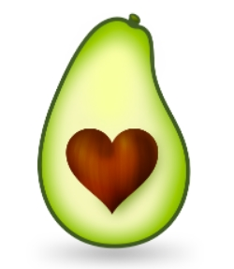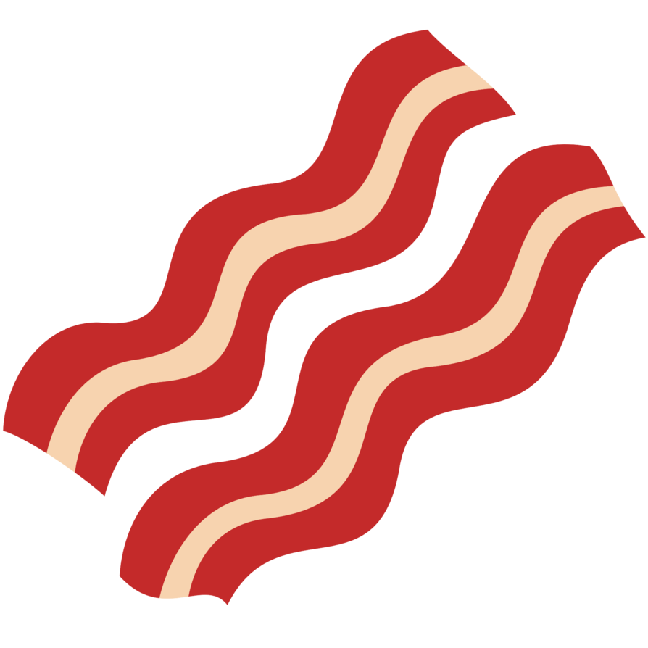 **Free Paleo Food! **

6:30- 6:42: **Mark Zerubi**, World Record Holder for Burpees in a 24 Hour Period, Reno, NV

“Training to Maximize Performance”

6:42- 6:54: **Paul Shonnard**, MD, Orthopedic Surgeon, Nevada Orthopedics, Reno, NV

“Recent Advances in Orthopedics”

6:54- 7:06: **Shana Fearnley**, PA-C, Nevada Orthopedics, Reno, NV

“Orthopedic Update on Femeroacetabular Impingement”

7:06-7:18: **Hilary L. Malcarney**, MD, Orthopedic Surgeon, Nevada Orthopedics, Reno, NV

“Shoulder Instability”

7:18-7:30: **Jim Fitzsimmons,** PhD, Director of Campus Health and Wellness, University of Nevada Reno

“Strength Training: How Long Should My Workout Last?”

7:30-7:42: **Dr. Robert Berry**, MD, Sports Physical Medicine & Rehabilitation, Sierra Regional Spine Institute

“Recent Advances in Spinal Health”

7:42-7:54: **TBA**

